# COMPSCI711 A1 REPORT

## Intrduction:

In this assignment I implemented the option2.And I have test it on a lab machine.\

### Guidance for runing this program:

First you can find a batch file named strat.bat .Double click it to start the project program.

And there will display three form windows which called CDNClient,CDNCache,and CDNServer.

### CDNClient

Click the “list all files”,the client will display all files that are avilable on server.And double click the file name ,the picture file will display on the right side.

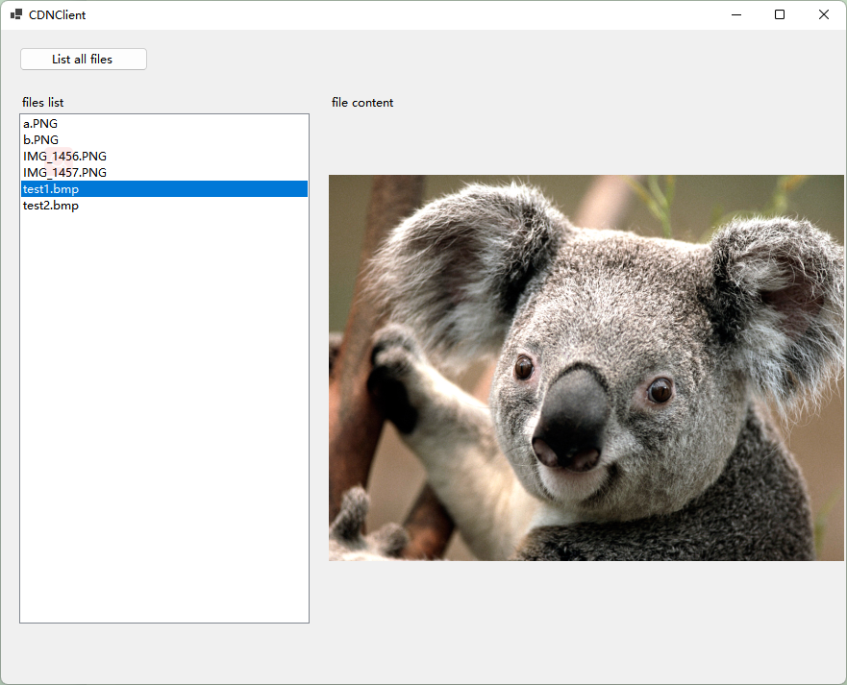

## CDNCache

The Cache side has three parts,Cache part shows the contents of the selected data fragment cached on the cache server.The file part shows the file list that requested by the client side.And couble click the file name to display the cache log .The log viwer shows the requested file name,the request time and the percent of the file that constructed by data fragments that stored on cache server.

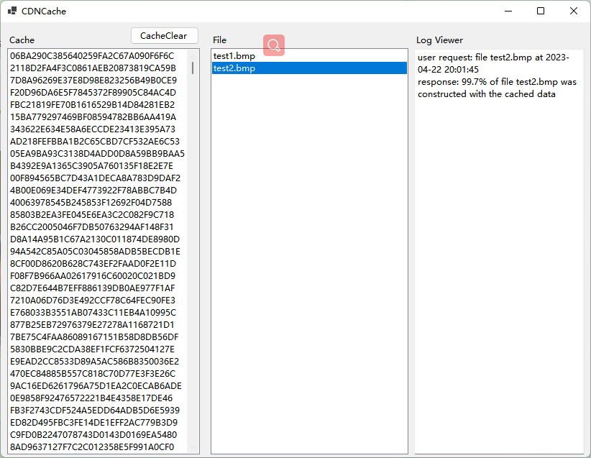

## CDNServer

The server side displays all files that is available for user when the the server initialize.And the button “Add File to server” allows administrator to add file to server.

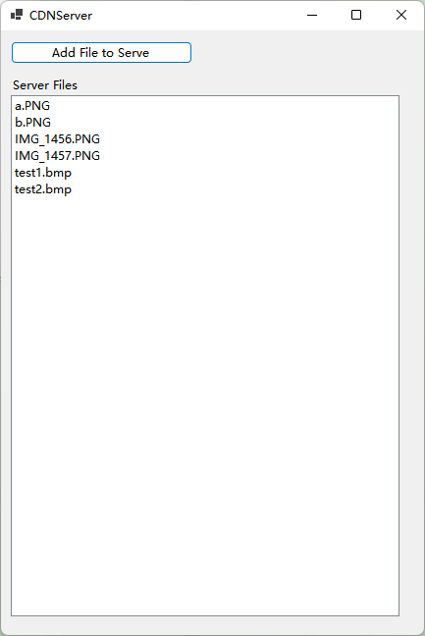

### The techniques I use to ditermine the fragment need to be download from the server:

I created two dictionary on cache side and server side as following code:

Dictionary<string, List<string>> FileCache = new Dictionary<string, List<string>>();

Dictionary<string, byte[]> FragmentCache = new Dictionary<string, byte[]>();

Create a new dictionary named FileCache :

The key is the filename, and the value is a list of md5 values for each block of the file. Used to store the md5 value of the corresponding file to facilitate the file content query for the following file block dictionary.

Create a new dictionary FragmentCache :

The key is the MD5 value corresponding to the block, and the value is the file contents (stored as a byte array). The downside is that the contents of the file are stored together, which works but is not a good solution.

For the server side, when the server is initialized and a new file is uploaded to the server, the file is splited into fragments by rabin function and stored in FileCache .And during spliting the file into fragment by rabin function,the server side will store the fragment into FragmentCache for future request.

For the cache side.When a download request is processed, the cache checks to see if the requested file exists in FileCache. If not, an ST request is sent to the server to get a list of MD5 values for the file requested. And store it in FileCache on the cache side. And then the cache iterates over the file's MD5 list in FileCache. Check whether the corresponding MD5 fingerprint of each fragment has a corresponding key/value pair in FragmentCache. If there is a fragment, it is stored directly in the buffer; if not, it sends an FR request to the server to download the corresponding fragment.

### Comparison with option 1:

1.Response time perceived by user:

For the brand new files ,the option2 need more time than option 1 .Because it needs extra time to split the file.For the old file ,it takes the same time as option1.And for a brand new file which is similar to a old file,It takes shorter time.

1. Network bandwidth:

For the brand new file,the bandwidth will increas because cache needs to download the md5 list for every file.For the old file ,it takes the same bandwidth with option1..And for a brand new file which is similar to a old file,It takes fewer bandwidth because it only needs to dowload the fragment that isn’t stored on the cache side.

3. Server-side and cache-side computation

Since the server side is responsible for segmenting the file and calculating the md5 digest,

the amount of computation on the server side is significantly increased.